Edward Hill

CTEC 128

Dr. Bemely

**PART 1 PYTHON**

1. **Hello World**

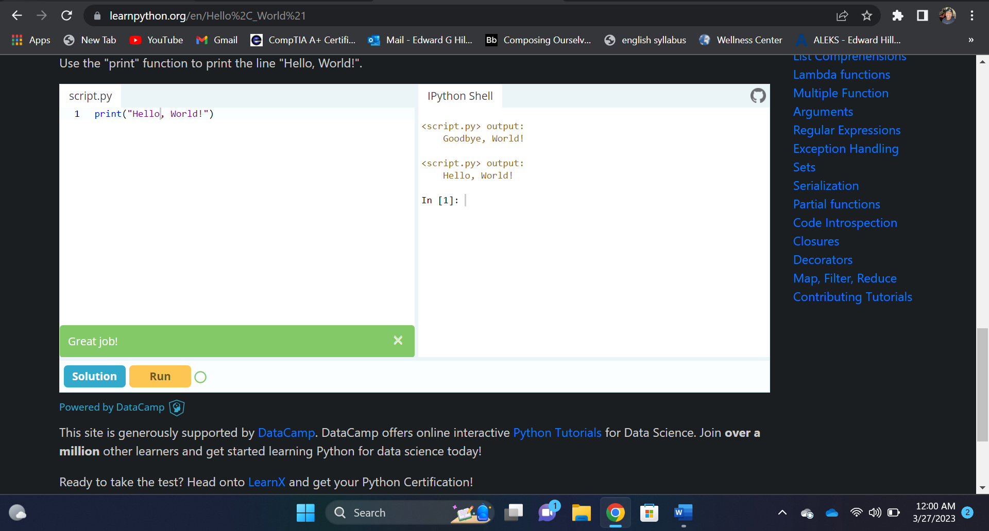

1. **Variables and Integers:**

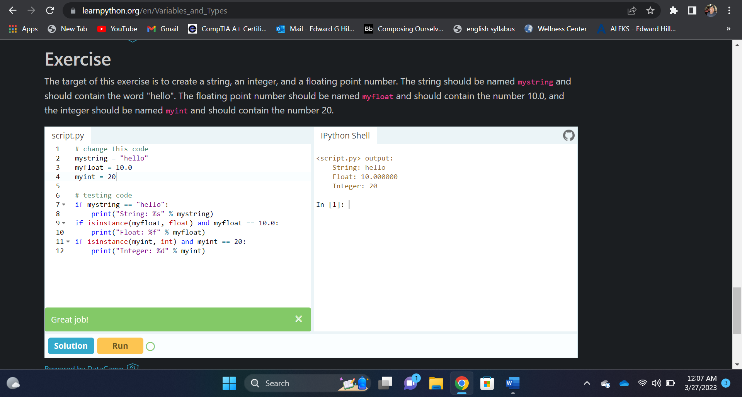

1. **LISTS:**

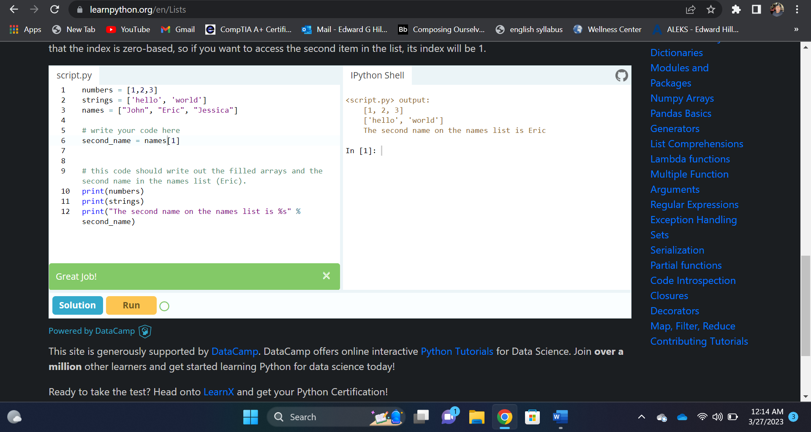

1. **BASIC OPERATERS:**

1. **String Formatting:**

1. **Basic String Operations:**

